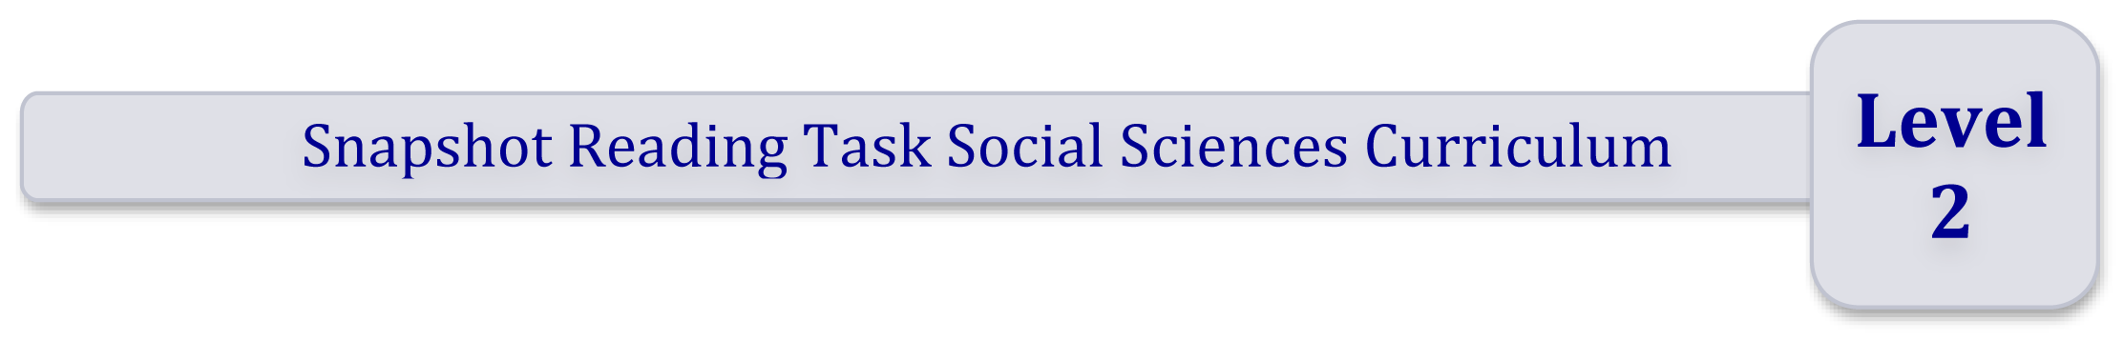

Using School Journals to support reading across the curriculum

The snapshot tasks below are designed as illustrated examples of planning interactive reading tasks at Level 2 within a Social Sciences inquiry. They are based on the inquiry question: How do people deal with conflict?

They are not intended to be sequential tasks, rather they provide a lens on the literacy demands that students need to engage with at a particular level of the curriculum.

How these snapshot tasks might be used?

- Use these as a model to support you as you plan other reading tasks for a particular level across the curriculum
- Adapt these tasks by interchanging texts and adjusting to meet specific learning needs
- Integrate these into your existing unit on the same theme
- Use these to prompt your thinking and planning for a broader social studies unit.

NEW ZEALAND CURRICULUM
Learning area
Social Sciences
LEVEL | 2
Focus of learning/topic | Overcoming differences: Dealing with conflict especially in times  of war
CONTEXT | World War 2
Values | Integrity and respect for themselves and others
Key competency | Thinking
CONCEPTUAL UNDERSTANDINGS | Conflict can have long-lasting consequences
Achievement objectives | Understand how time and change affect peoples’ lives
Learning Process | Exploring values and perspectives
English Achievement objectives | Processes and Strategies: Select and use sources of information, processes and strategies with some confidence to identify, form, and express ideas.  Ideas: Show some understanding of ideas within, across and beyond texts.
RESOURCE
TITLE | Part 2 No 1 2006. Great-grandpa, Sue Gibbison
STORY SUmmary | A boy talks with his Great-grandpa about the consequences of war  and terrorism.
INSTRUCTIONAL FOCUS | Locate and evaluate information and ideas within texts as they  generate and answer questions  - Locate and summarise main ideas by identifying key words, topic sentences  - Making and justifying inference (using information close by in the text)  - Making connections between the text and their prior knowledge to interpret figurative language  - Can discuss their response to a variety of texts.

PLANNING
SKILLS AND KNOWLEDGE | What skills and knowledge do my students bring to the learning?
SUPPORT | What support will my students need to:  - Identify and summarise main ideas  - Use knowledge of text structure – e.g. topic sentences  - Ask and answer questions about the ideas in the text  - Make and justify inferences – using information that is close by in the text  - Evaluate the effectiveness of a text for a particular purpose.

ACTIVITY
EXPLAIN THE SETTING/THEME | The story is set on 11 September 2001 and triggers memories for  Great-grandpa of his time in combat during WWII.
QUESTIONS:  EXPLORING VALUES AND PERSPECTIVES | How has the experience of war influenced the way that Great-grandpa thinks and acts?
EXPLORE THE TEXT | Before reading the text ask the students what they know about the World War 2?  What questions do you have about what it was like for people like Great-grandpa who experienced war?  Begin by working together as a group using the answers to the students’ own questions, and the prompts and questions below, to add ideas to a chart. An example chart  is provided below.  - Locate the words and phrases that Great-grandpa used to describe the day he remembers. E.g.: Blue sky, no wind, quiet as the grave...  - Locate the paragraph that describes what happened to Great-grandpa. E.g.: “Suddenly BOOM! The guns go off on both sides of us ... I couldn’t hear for weeks afterwards”  - How does Great-grandpa feel about war? How does the narrator feel about war?  - How does Great-grandpa feel about smoking? How are his feelings the same about smoking and war?  Once students have a clear understanding of what to do, set them to work independently or with a partner to complete the chart.  Later, bring students together to discuss their findings and help them to come to some general understandings about why Great-grandpa felt the way he did about war.
SAMPLE ACTIVITY CHART
Words/phrases from the story showing what Great-grandpa saw heard and experienced |  | What this tells me about Great-grandpa and about war (Making and justifying inferences)
Blue sky no wind, quiet as the grave ... |  | War can happen at any time.
Suddenly boom! The guns go off on both sides of us …  I couldn’t hear for weeks afterwards” |  | War is frightening and very deadly.
“War is a terrible thing… That was the day I started smoking. Lost my hearing and started smoking. And I was one of the lucky ones!” |  | Some of Great-grandpa’s friends were killed. He was not. He felt lucky to be alive.  He started smoking because he thought it would make him feel better.
You would think people would know better now… |  | War is still going on.  Smoking isn’t a good thing either.

REFLECTION
Students can use their reading  and discussions through the chart above to develop drawings  with thought bubbles | Example:  How Great-grandpa feels about war.  War is frightening  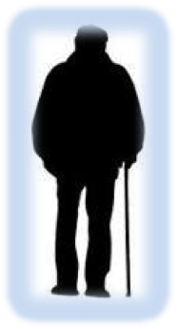
The thought bubbles might be added into topic books to help build students’ understanding of the consequences of war on individuals. | What he thinks about smoking the pipe now.    Smoking doesn’t make me feel better
Students might like to record  their thinking/learning so far  in their notebooks | My thinking about war based on what I have read, and discussed so far is …  I would like to find out more about …

